Parish newsletter resources for use to promote the Third National Collection for WMOF2018 on 24 and 25 February 2018

- Background article on WMOF2018:
This article can be used in whole or in part to give a sense of background information on the World Meeting of Families 2018.
Dublin, Ireland has the great joy of hosting the 9th World Meeting of Families that will take place in just under seven month’s time from the 21 – 26 August 2018. The sense of excitement, expectation and anticipation is building by the day as we prepare to welcome families from across Ireland and across the world to our family gathering.
The World Meeting of Families was established in 1994 when Pope Saint John Paul II asked the Pontifical Council for the Family to establish an international gathering of prayer, catechesis and celebration that would draw participants from around the world and that would help to strengthen the bonds between families and bear witness to the crucial importance of marriage and the family to all of society.
And, so the World Meeting of Families was established and to date it has been hosted in Rome, Rio de Janeiro, Milan, Valencia, Mexico City and Philadelphia. Now it’s our turn here in Ireland because Pope Francis has personally chosen Dublin to be the host city for the next World Meeting of Families and he has invited us to reflect on the theme ‘The Gospel of the Family: Joy for the World’.
The main events of WMOF2018 will take place in Dublin but it is also anticipated that related events, including the hosting of international groups, will take place all over the island of Ireland.
The following key moments make up the 9th World Meeting of Families:
- A National Opening on Tuesday 21 August which will take place simultaneously in each of the dioceses of Ireland;
- A three day congress from 22-24 August in the RDS, Dublin;
- A Festival of Families on Saturday 25 August, comprising a reflective concert style event within a prayerful and joyful atmosphere, in which personal stories of faith will be shared by families from all continents;
- A Closing Mass will be celebrated on Sunday 26 August with thousands of people from Ireland and across the world.
Pope Francis has asked us to prepare for the 9th World Meeting of Families by reflecting on ‘Amoris Laetitia (The Joy of Love)’, his apostolic exhortation released in 2016. Pope Francis believes that the family is good news for today’s world. The Amoris: Let’s Talk Family! Let’s Be Family! Programme is a response to this request from Pope Francis.
We are inviting families in our parish to join us on our journey of preparation for the World Meeting of Families and to be part of the events in Dublin from 21-26 August 2018. Please support us by volunteering, registering to attend and donating at our parish collection.
- Parish Newsletter notices x 4
Notice 1: For weekend of 10 and 11 February 2018
Text version
Please support the third National Collection for WMOF2018 which will be taken up in our parish on the weekend of 24 & 25 February 2018.
Image version – downloadable version is attached
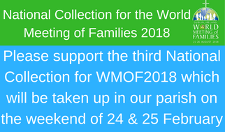

Notice 2: For weekend of 17 and 18 February 2018
Text version
Please support the third National Collection for WMOF2018 which will be taken up in our parish next weekend - 24 & 25 February 2018.
Image version – downloadable version attached
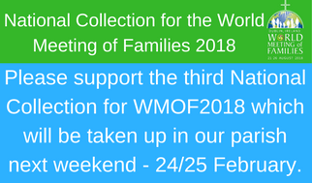

Notice 3: For weekend of 24 and 25 February 2018
Text version
Please support the third National Collection for WMOF2018 which will be taken up in our parish this weekend (24 & 25 February).
Image version:
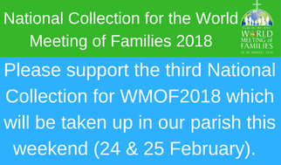

Notice 4: A Thank You message for sharing on weekend of 3 and 4 March 2018
Text version
Thank you for your support of last weekend's parish collection for WMOF2018.
Image version:
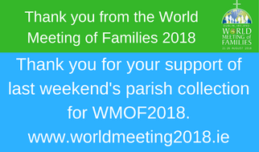
These four visuals are also attached for printing purposes.
ENDS

