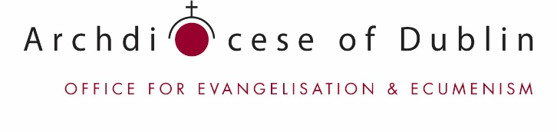

Thursday Evening Course, Holy Cross College, Clonliffe Road, Dublin DO3P2E7.

PATHWAYS
Exploring Faith as an Adult
Applications for September 2019 are now open. Early application is advised!
The Pathways Programme is suitable for adults of all ages who wish to explore issues and questions of: faith; the nature of belief, ministry and the Church today and into the future, in an environment appropriate to Adult Learning and Adult Faith Development.

The Course
The programme runs over two years from late September to late May each year. It takes place on Thursday evenings from 7.00p.m. – 9.30 p.m. in Holy Cross College, Clonliffe Road, Dublin DO3 P2E7. There are three optional Saturday sessions each year. The programme this year will be starting on Thursday 26th September 2019.

Who is the Course for?
This course is suitable for men and women of all ages and from all walks of life who are looking for an opportunity to consider questions about belief and Church today and into the future.

Course Aims
The course values the life experience which the participants bring and, accordingly, group sharing is an integral part of the learning process each year. The course also offers the spiritual and theological formation which will enable participants to explore their faith with greater confidence. It also helps assist people to prepare themselves to respond to the needs of the Church and community and to work in partnerships and parish teams. Participants have an opportunity to take part in various liturgies and times of Directed Prayer during the year.

Course Entry Requirements
The main requirements are: a desire to explore faith; openness to participation; a willingness to listen and an interest in new ideas and approaches to ministry. No academic qualifications and no previous study in theology or spirituality are necessary. There is no required written work and there are no exams.

Course Cost
Fees are €400 each year. Fees may be paid in full at the beginning of the year or in instalments throughout the year. Part-sponsorship may be available from some parishes.

Course Content
First Year – In the first year the emphasis is on the personal experiences and the faith journeys of the participants. Subjects include: How Adult Learn; Stages of Faith; Images of God; Introduction to Scripture; Celebrating the Church’s Year; the Person of Christ; Personal Journey; Sacraments; the Moral Life; Spirituality and Prayer.
Second Year – The focus of the second year is on Christian living, the Gospel call and how we respond to it. Subjects include: Visions and Models of Church; Approaches to Ministry; Bereavement and Loss; Family; Pastoral Issues Today; Justice and Peace, Ecumenism; Ecology; Caring for Yourself.

For further information please contact:
Eileen Houlahan, CHF, PhD
Director, Pathways Programme, Office for Evangelisation and Ecumenism, Holy Cross Diocesan Centre,
Clonliffe Road, Dublin 3, D03 P2E7.
Tel: +353 1 8087594
Email: ehoulahan@dublindiocese.ie; pathways@dublindiocese.ie

