j0344483



***‘O Lord, support us all the day long,***

***until the shades lengthen and the evening comes***

***and the busy world is hushed,***

***the fever of life is over, and our work is done.***

***Then, Lord, in your mercy grant us safe lodging,***

***a holy rest and peace at the last.’***

**‘Into your hands O Lord, I commend myself, my spirit, soul and body.   
It was you who made me and redeemed me,   
and together with me all my friends and loved ones.   
You have entrusted them to me, Lord, in your great goodness.   
Guard my lying down and my rising up,   
may I lie down in peace and may sleep come at once, for you alone Lord make me dwell in safety.’**

***‘Lead kindly Light, amid the encircling gloom,***

***lead thou me on.***

***The night is dark and I am far from home,***

***lead thou me on.***

***Keep thou my feet, I do not ask to see***

***the distant scene; one step enough for me.***

***I was not ever thus, nor prayed that thou***

***should’st lead me on.***

***I loved to choose and see my path, but now***

***lead thou me on.***

***I loved the garish day and, spite of fears,***

***pride ruled my will: remember not past years.***

***So long thy power hath blessed me,***

***sure it still will lead me on.***

***O’er moor and fen, o’er crag and torrent, till***

***the night is gone.***

***And with the morn those Angel faces smile,***

***which I have loved long since and lost awhile.’***

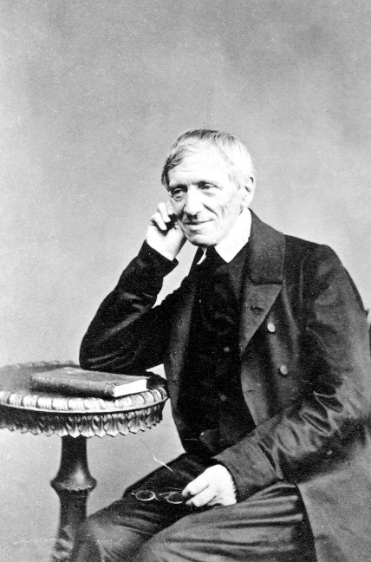

*Prayers and Reflections of*

**JOHN HENRY NEWMAN**

1801-1890

***Declared a Saint***

***13th October 2019***

***‘God beholds you individually whoever you are.***

***He sees you and understands you because he made you.***

***He looks on you in your day of rejoicing***

***and in your day of sorrow.***

***He interests himself in all your anxieties and remembrances,***

***all the rising and falling of your spirit.***

***You do not love yourself better than he loves you.’***

* *

***‘Life passes, riches fly away, popularity is fickle,***

***the senses decay, the world changes, friends die.***

***One alone is constant;***

***One alone is true to us;***

***One alone can be true:***

***One alone can be all things to us;***

***One alone can supply our needs;***

***One alone can train us up to our full perfection;***

***One alone can give a meaning to our complex and intricate nature; One alone can give us tune and harmony;***

***One alone can form and possess us.’***

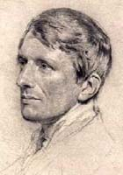

***Our Calling***

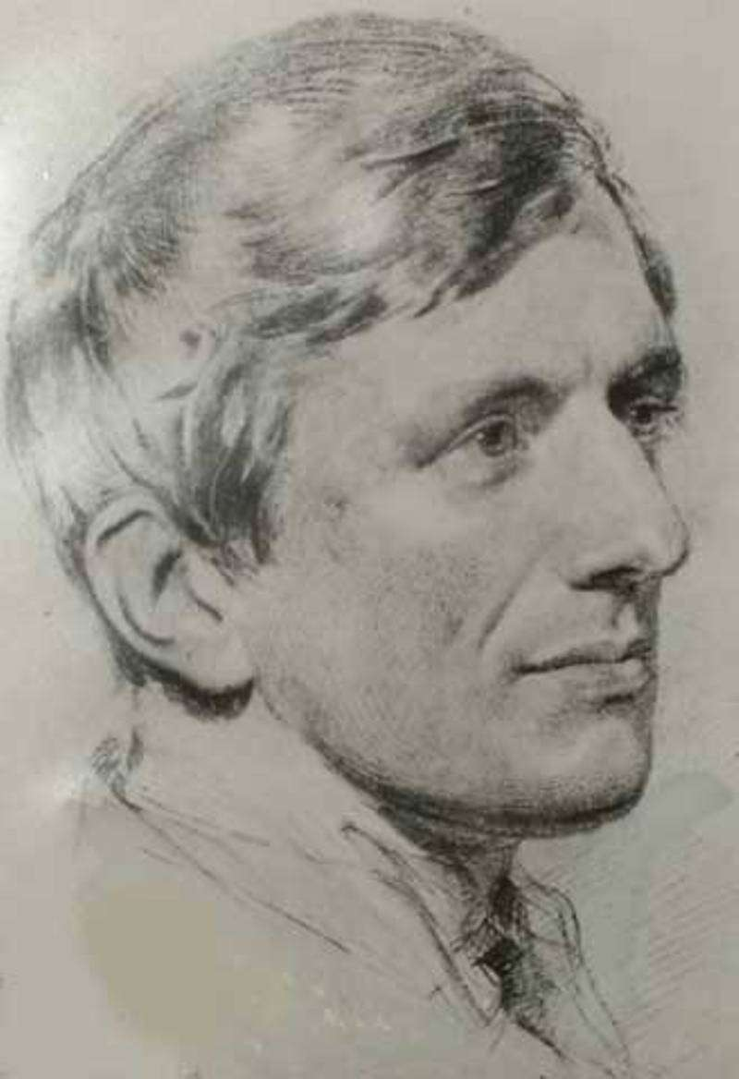

***BE STILL…  
‘It is thy very energy of thought which keeps thee from thy God.’***

***’By night I will lift up my hands to the holy place and bless the Lord.  
By day the Lord has sent his loving kindness.***

***By night I will sing praise to the God of my life.’***

***‘To live is to change,***

***and to be perfect   
is to have changed often.’***

***‘Fear not that your life shall come to an end, but rather fear that it shall never have a beginning.’***

***‘All through our life Christ is calling us.***

***He called us first in Baptism; but afterwards also;***

***whether we obey his voice or not,***

***he graciously calls us still…***

***He calls us on from grace to grace,***

***and from holiness to holiness, while life is given us…***

***We are all in course of calling, on and on,***

***from one thing to another, having no resting place,***

***but mounting towards our eternal rest,***

***and obeying one command only to have another put upon us.***

***He calls us again and again, in order to justify us again and again – and again and again, and more and more,***

***to sanctify and glorify us.***

***It were well if we understood this,***

***but we are slow to master the great truth,***

***that Christ is, as it were, walking among us,***

***and by his hand, or eye, or voice, bidding us follow him.***

***We do not understand that his call***

***is a thing which takes place now.***

***We think it took place in the Apostles’ days,***

***but we do not believe in it,***

***we do not look out for it in our own case.***

***We have not eyes to see the Lord...’***



***‘God has created me to do Him some definite service.***

***He has committed some work to me***

***which He has not committed to another.***

***I have my mission.***

***I may never know it in this life,***

***but I shall be told it in the next.***

***I am a link in a chain,***

***a bond of connection between persons.***

***He has not created me for naught.***

***I shall do good; I shall do His work.***

***I shall be an angel of peace,***

***a preacher of truth in my own place, while not intending it***

***if I do but keep His commandments.***

***Therefore, I will trust Him, whatever I am,***

***I can never be thrown away.***

***If I am in sickness, my sickness may serve Him,***

***in perplexity, my perplexity may serve Him.***

***If I am in sorrow, my sorrow may serve Him.***

***He does nothing in vain.***

***He knows what He is about.***