

**Lord our God, you said that “the harvest is rich but the laborers are few. Pray, therefore, the Lord of the harvest to send labourers into his fields.”**

**Lord, we pray for your Spirit to send us holy priests. To ignite the spark inside men to faithfully minister as priests in the Archdiocese of Dublin.**

**Fill them with zeal to come forward with a heart on fire with divine love, so they may become mirrors of Christ, your Son, in a world in need of His light, meaning, hope and courage.**

**Send to the Archdiocese of Dublin, strong and courageous spiritual shepherds, fearless in proclaiming the Resurrection of Christ anew for our time. May these men of prayer be always open to the responsible call of service to your beloved people.**

**We ask this through Christ Our Lord. *Amen*.**

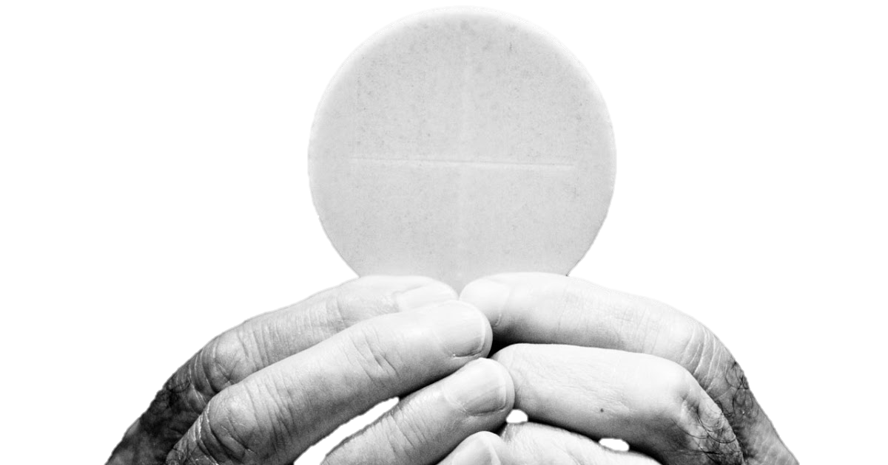

**

www.dublindiocese.ie/vocations



**A Prayer for Vocations to the Priesthood**

