DUBLIN DIOCESAN LITURGICAL RESOURCE CENTRE

In place of our Annual Winter/Spring Seminar we invite you to join us for 3 Online Liturgy Tuesdays with presentations and chats where ideas can be shared.
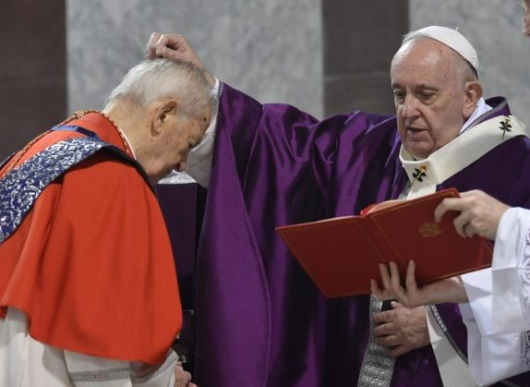
Tuesday 26th January 2021 8.00 – 8.45p.m. on ZOOM
- How we can celebrate the season of Lent in COVID times?
Topics will include the possible remote blessing of ashes in the home (‘the domestic church’) and the latest Roman directive on distributing ashes.
- Ideas will be shared on the adaptation of the Lenten rituals of the Rite of Christian Initiation of Adults for online parish prayer services and retreats.
- Trócaire’s Liturgy resources for Lent 2021 will also be explored.
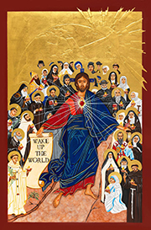
Presented by Pat O’Donoghue, Damian McNeice and Mary Coogan from Trócaire.
Tuesday 2nd February 2021 8.00 – 8.45p.m. ONLINE
Day for Consecrated Life
A live online celebration of the gift and grace of Religious and Consecrated Life hosted by the Redemptoristine Sisters of the Monastery of St Alphonsus Drumcondra on World Day for Consecrated Life. www.rednuns.com

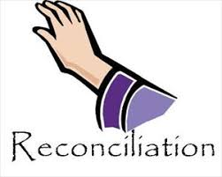
Tuesday 9th February 2021 8.00 – 8.45p.m. ZOOM
How do we reconcile in COVID time?
Lent is the time of Reconciliation in our liturgical year, we will look at models for celebrating online Reconciliation Services with an eye on engaging participants and promoting active involvement including art, music and movement.
Presented by Damian McNeice, Pat O’Donoghue and Audrey Darby.

Book Your Place
Email Lisia Cashen at the Office of Administration – lisia.cashen@dublindiocese.ie to secure your place for the two Zoom presentations. Our licence limit is 100 people per session. Please reserve a place only if you are sure that you will be able to accept it. Links are not to be shared for security reasons. The middle session (2 Feb) is available on the internet and no booking is needed. We look forward to seeing you online.

