RECONCILIATION SERVICES – COVID LENT 2021
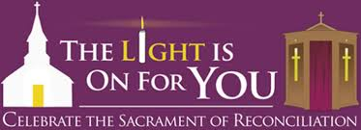

Here is a template for creating a Penance/Reconciliation Service during Covid times which can also serve as a framework for other occasions.

- Gather a group online to agree a date and plan the service
- Begin with a time of quiet so that all may settle and prepare inwardly
- It is essential that the person who leads the service is present
- Agree one piece of scripture from which the service will flow
- Locate visuals to complement the verses of scripture chosen
- Select suitable music that will help open up the participants
- Research reflections or psalm lines that make connections with the scripture
- Build in silences so that all can breathe – leave room for the Holy Spirit
- Punctuate the service with opportunities for active participation
- Finish with a blessing for all and propose a challenge that is achievable.

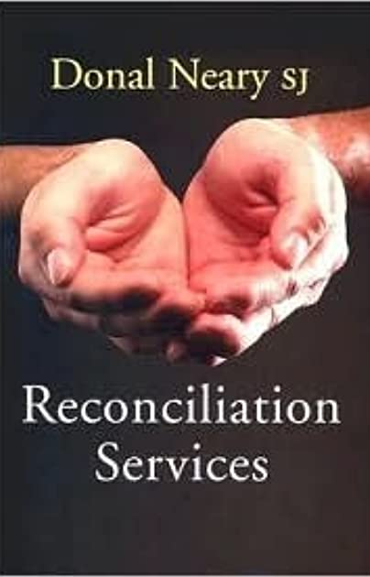
Some Practical Questions
How do you fix the time?
How do you advertise/promote the event?
What will the people see when they log on?
Will there be a service sheet/roadmap?
How will the coordination of speakers etc. happen?
Is there an overall coordinator or team?
What about rehearsal?
Will there be regular contact between the planners?
Is there a backup plan for emergencies?
Will it be recorded?
Is there an evaluation plan?
What about individual confessions in the Church at another time?


Service of Reconciliation - Examination of Conscience – The Lord’s Prayer

- Our Father who art in heaven …
We’re all in this together. The Lord’s Prayer is a communal prayer just as this is a communal celebration of the Sacrament of Reconciliation. Jesus invites us to meet him in the Sacrament of Reconciliation not only as individuals but as members of a community of believers who have much in common.

Do we think of others when we pray or are we selfishly focused on ourselves?
Do we recognise the responsibility we share for each other’s welfare?

If we have failed in this way, we ask forgiveness:
Lord, have mercy – Lord, have mercy

- Hallowed be Thy name …
We ‘holy’ by virtue of our Baptism and our mission is to preserve that grace throughout our lives.

Do we live in a way that is truly wholesome and good?
Do we try to develop a sense of holiness and respect for life?

If we have failed in this way, we ask forgiveness:
Lord, have mercy – Lord, have mercy

- Thy Kingdom come
We can create heaven on earth by living up to the example of Jesus who is merciful, inclusive and just.

Do we build up the kingdom of justice and truth or do we destroy it by our greed?
Do we create an atmosphere of love around us or are we cold and detached?

If we have failed in this way, we ask forgiveness:
Lord, have mercy – Lord, have mercy

- Thy will be done on earth as it is in heaven
Jesus gives us the supreme example of obedience to the will of God by his prayer in the Garden of Gethsemane – ‘let thy will not mine be done’.

Do we avoid the hard things in life and take the easy way out?
Do we adopt the motto ‘my way or the highway’ because of pride and lack of humility?

If we have failed in this way, we ask forgiveness:
A Thiarna, déan trócaire, A Thiarna, déan trócaire
- Give us this day our daily bread
This prayer encourages us to live in the present praying for our current needs and nourishment. It also opens up the challenge of acknowledging the needs of the whole community for both spiritual nourishment and the vital sustenance in life.

Do we waste time and energy in worrying about the future and ignoring the present?
Do we look beyond our own hunger for nourishment to the plight of victims of famine?

If we have failed in this way, we ask forgiveness:
A Thiarna, déan trócaire, A Thiarna, déan trócaire

- And forgive us our trespasses
We need to know our own weaknesses and failings before we can ask for forgiveness. This calls for a great deal of honesty, courage and humility.

Do we always blame others for our own mistakes and ignore the truth?
Do we take time to listen when others are trying to point out our faults?

If we have failed in this way, we ask forgiveness:
A Thiarna, déan trócaire, A Thiarna, déan trócaire

- As we forgive those who trespass against us
These two phrases of the prayer go hand in hand. We don’t understand God’s forgiveness if we cannot forgive ourselves and others in turn?

Do we hold on to past hurts making our own lives and those of others a living hell?
Do we meet others half way or make it difficult to mend fences?

If we have failed in this way, we ask forgiveness:
Christe, eleison, Kyrie, eleison, Christe, eleison

- And lead us not into temptation
We all know the reality of the slippery slope of temptation – we think that we can be strong and full of resistance – the spirit is willing but the flesh is weak.

Do we avoid situations, people and places that will lead us to fall into bad habits?
Do we think through pride that we can manage our addictions on our own?


If we have failed in this way, we ask forgiveness:
Christe, eleison, Kyrie, eleison, Christe, eleison
- But deliver us from evil
We are invited to place our trust in God who will protect us from harm. However, we have to cooperate with God to keep us from harm.

Do we dismiss the presence of evil in our arrogance?
Do we lack trust in God placing ourselves and our opinions above all else?

If we have failed in this way, we ask forgiveness:
Christe, eleison, Kyrie, eleison, Christe, eleison

Act of Sorrow
All say : O my God, I thank you for loving me.
I am sorry for all my sins,
For not loving others and for not loving you.
Help me to live like Jesus and try not to sin again.

Music Abwoon (Our Father) by Lisa Gerrard and Patrick Cassidy

Athair ar Neamh by Enya

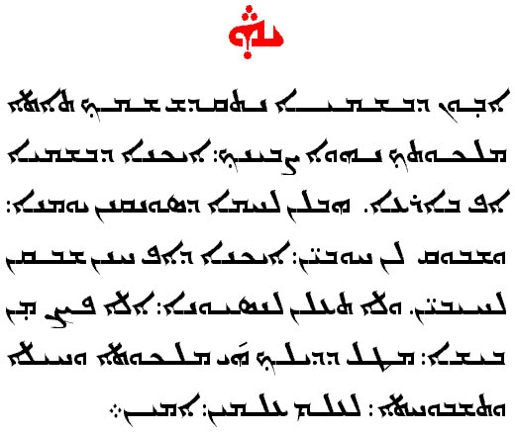
Our Father in Aramaic

