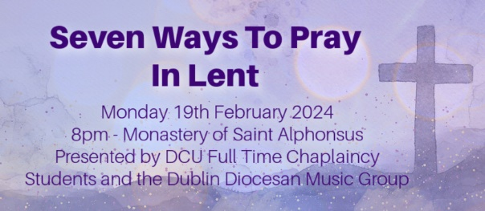

‘Being’ in the Wilderness – 1st Week of Lent

Song Hosea (Monks of Weston Priory)
All sing: Come back to me with all your heart.
Don't let fear keep us apart.
Trees do bend, 'though straight and tall;
so must we to others' call.
Long have I waited for your coming home to me
and living deeply our new life
The wilderness will lead you to the place where I will speak.
Integrity and justice with tenderness you shall know.
Long have I waited for your coming home to me
and living deeply our new life.

Jesus’s public ministry began when he was about 30 years old and would last about 3 years…give or take.
It all started on the river Jordan when one day Jesus showed up and was baptised. As his cousin John pulled him up out of the water we read that the Spirit descended on him like a dove. And a voice came from heaven:
“You are my Son, whom I love; with you I am well pleased.”
Jesus had received his confirmation from God. You are my son, whom I love;
with you I am well pleased.
It’s interesting that the Father loved and was pleased with Jesus before he even did anything. This is it. This is the start of this great adventure. Or is it?

We read:
‘The Spirit drove Jesus out into the wilderness and he remained there for forty days, and was tempted by Satan. He was with the wild beasts, and the angels looked after him.’

Before Jesus could do his work in front of the crowds that were screaming and shouting for him, he first needed to hear the gentle whisper of God in the
wilderness.
Before he could feed the thousands, he needed to experience physical hunger.
Before he could serve the Father fully, he needed to remember upon whom he was reliant.
Jesus being sent to the desert is a reminder to us that we are not God and that
sometimes we too need to be told to stop and go to the wilderness for a time.
A time where we can be still and sit in the presence of God before we go out to do the incredible work God has planned for us.
We’re human beings, not human doers. Lent isn’t all about action?

Where is your wilderness space? Can you go there to pray or to simply ‘be’?
Brief pause

I invite you now to repeat after me what I say
Be still and know that I am God
Be still and know that I am
Be still and know
Be still
Be
Brief pause

Song Be Still and Know

Praying for Transformation – 2nd Week of Lent

From the Gospel of Mark 9:2-7
“Jesus took with him Peter and James and John and led them up a high mountain where they could be alone by themselves.
There in their presence he was transfigured: his clothes became dazzlingly white, whiter than any earthly bleacher could make them.
Elijah appeared to them with Moses; and they were talking with Jesus.
Then Peter spoke to Jesus. ‘Rabbi’, he said ‘it is wonderful for us to be here; so let us make three tents, one for you, one for Moses and one for Elijah’. He did not know what to say; they were so frightened. And a cloud came, covering them in shadow; and there came a voice from the cloud,
‘This is my Son, the Beloved. Listen to him’ “.

We may see the story of the transfiguration as one of the most alien and remote stories in the Gospels. However if we bring it down to earth it challenges us to transform our lives in a very simple but impactful way. The vehicle for this change is prayer as Saint Teresa of Calcutta notes:
‘the fruit of silence is prayer; the fruit of prayer is faith; the fruit of faith is love; the fruit of love is service; the fruit of service is peace.’
We need to sit in silence and take a breath and clear our minds before we pray.

According to Gregory of Nyssa, prayer gives us a share in God’s power not in the sense of turning water into wine but the way it enables us to see the world differently and gives us the courage to perform loving acts of service or what I like to call mundane miracles. This can be as simple as making the effort to volunteer or check in on a neighbour or reconnect with a friend you have not spoken to for a while. You would be surprised how these acts can change and transfigure your own life and the lives of those around you.

Do you listen to God’s promptings? How is prayerful action in your life?
Can you recall being transformed by the kindness and affirmation of another?
Brief pause

Song: Servant Song (Richard Gillard)
Will you let me be your servant,
Let me be as Christ to you;
Pray that I may have the grace to
Let you be my servant, too.
We are pilgrims on a journey,
We are trav'lers on the road;
We are here to help each other
Walk the mile and bear the load.

Spiritual Fasting, Lasting Transformation
St. Teresa of Avila, a Carmelite nun, often explains prayer as, “nothing else than an intimate sharing between friends; it means taking time frequently to be alone with Him who we know loves us.”
During this time of Lent, we seek to explore different ways of praying in the spirit of the season in preparation for Easter. In many Church traditions present around the world, fasting is an important element, for example Ramadan.
Fasting, for me, is not merely abstaining from food, but a heartfelt surrender of my desires and inclinations that hinder my relationship with God and others. I invite each of you to think about what fasting is for you.
Brief pause
There are many ways in which we can offer a moment of fasting apart from food and drink. What about the amount of time we spend scrolling on our phones or even checking them for messages? This is time that could be spent with our eyes open, noticing the struggle of others or simply seeing Christ in the person before us. Do we offer a helping hand to the homeless person we pass in the street or are we too preoccupied to even notice them; do we read the Bible or say a prayer or do we simply offer a beautiful smile in passing another. These may seem like simple gestures yet they offer us a profound and lasting opportunity to deepen our spiritual awareness in what we offer to Christ in the people around us. Spiritual fasting is lasting and makes a difference.
Brief pause

Prayer
God of love and compassion,
As Saint Teresa found joy in Your love,
may we too discover the lasting joy of a friendship with You
and the people around us.
Let our hearts be filled with Your peace, our minds with Your wisdom,
and our souls with Your presence.
In our spiritual journey, guide us to cultivate a fasting that is pleasing to You
—one that brings transformation, growth, and a deeper communion with You.
May our lives reflect the beauty of Saint Teresa's friendship with You,
shining as beacons of Your love and mercy in this world.
Servant Song ctd.

I will hold the Christ-light for you
In the night-time of your fear;
I will hold my hand out to you,
Speak the peace you long to hear.
I will weep when you are weeping;
When you laugh I'll laugh with you.
I will share your joy and sorrow
'Til we've seen this journey through.
When we sing to God in heaven
We shall find such harmony,
Born of all we've known together
Of Christ's love and agony.

My Prayer for Forgiveness - 3rd Week of Lent

This evening I am focusing on self-forgiveness, so I invite you to join me in this prayer of forgiveness…

All Say - Prayer on Forgiveness
God of Mercy and Forgiveness,
help me to forgive myself and turn over a new chapter of my life.
God of compassion and generosity,
Mould me in Your image and make me a vessel for Your good work.
Build me a new life. I want to walk next to You all the days of my life.
I want less of me and more of You. I want to be undone by who You are.
So, Lord, I turn myself over to You.
Please help me to forgive myself and give me the strength to move on. Amen

From the Gospel of John
Just before the Jewish Passover, Jesus went up to Jerusalem, and in the Temple he found people selling cattle and sheep and pigeons, and the money changers sitting at their counters there. Making a whip out of some cord, he drove them all out of the Temple, cattle and sheep as well, scattered the money changers’ coins, knocked their tables over and said to the pigeon-sellers, ‘Take all this out of here and stop turning my Father’s house into a market.’

Scripture & Self forgiveness
On the third Sunday of Lent, we find a powerful message in the Gospel of John. Here we see a completely new side to Jesus, he gets so angry that that he flips tables and chases merchants out with a whip. Christ then continues by telling those surrounding him to destroy the temple and in three days he would raise it again. They believe he is talking about the Temple they were standing in but later understand Jesus spoke of his resurrection.

I don’t know about you but for me Lent is a challenge. It starts off good and I think “oh this will be easier this year” but then nope! The tiredness sets in, the struggle not to give in sets in, and this state causes so much emotion. When I get to that stage in Lent when it gets tough and when I forget and break my fast, I feel so guilty and disappointed in myself.
I used to go to speak to a friend of mine when I felt this guilt and he would say “be gentle with yourself” … “be gentle with yourself” …. For anyone who feels similar during Lent or at any stage during life please remember to be gentle with yourself. God forgives our sins so through him we must forgive ourselves. We all must be gentle and mindful of how we speak to ourselves.
Brief Pause

Song Gentle His Love (Marie Dunne CHF)

Dear me, I forgive you…
Dear Me, I forgive you.
I forgive you for not knowing everything, for not being perfect, for stumbling, being afraid, making mistakes, choosing poorly, and not thinking you were worthy of happiness.
I am also sorry. I am sorry that you tried so desperately to fix others when your own hands were shaking. I’m sorry that I didn’t give you enough time to heal, that I let you seal the wounds of everyone else whilst your own were bleeding. I’m sorry that there were days when smiling hurt, but you forced yourself to laugh so that no one had to worry about you. And I am so sorry that I did not love you, like you deserved to be loved.

There were times you were wrong. You are more than worthy of your own affection and self-care. So, for the times you neglected yourself I forgive you.
Love, Me.



Praying for Hope – 4th Week of Lent

Song Ag Críost an Síol (Seán Ó Riada)
Ag Críost an síol, ag Críost an fómhar;
i n-iothlainn Dé go dtugtar sinn.
Ag Críost an mhuir, ag Críost an t-iasc;
i líonta Dé go gcastar sinn.
Ó fhás go h-aois, is ó aois go bás,
do dhá láimh, a Chríost, anall tharainn.
Ó bhás go críoch, ní críoch ach athfhás,
i bParthas na ngrás go rabhaimid.
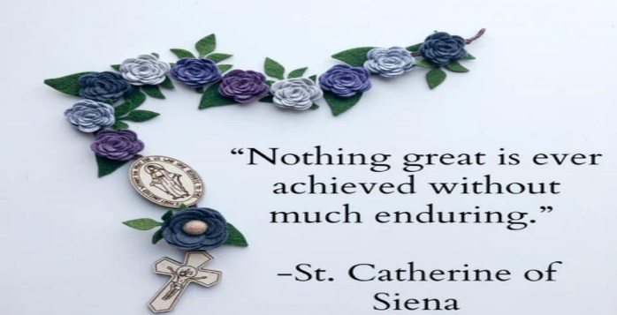
(Christ's is the seed, Christ's is the crop,
in the barn of God may we be brought.
Christ's is the sea, Christ's is the fish,
in the nets of God may we be caught.
From growth to age, from age to death,
Thy two arms, O Christ, about us.
From death to end, not end but growth,
in blessed Paradise may we be.)
The fifth Sunday of Lent: John 12:20.
Jesus replied, I tell you, most solemnly, unless a wheat grain falls on the ground and dies, it remains only, a single grain, but if it dies, it yields a rich harvest.

Where in the past week, did I let go of something?

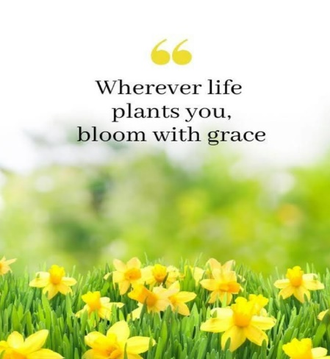
Lent is a journey to Hope. When we sit at Jesus’ feet, we hope for what is to come and what is possible, blossoms. May this Lenten season bloom hope afresh in our hearts. It is a time of reflection and renewal. “For everything, there is a season and a time for every matter under heaven”: we too can sow seeds of goodness. When we die to our own selfishness we rise to the new life of boundless hope and love.

“The delicate beauty of a daffodil is a reminder of the fragility of life and the importance of cherishing every moment”. Daffodils are like little rays of hope, shining bright in a world that can sometimes be dark.

Where do I encounter the God of Hope in my life?
Brief pause

Prayer for Hope:
Lord, I find hope in your unfailing love.
Your love is a rock.
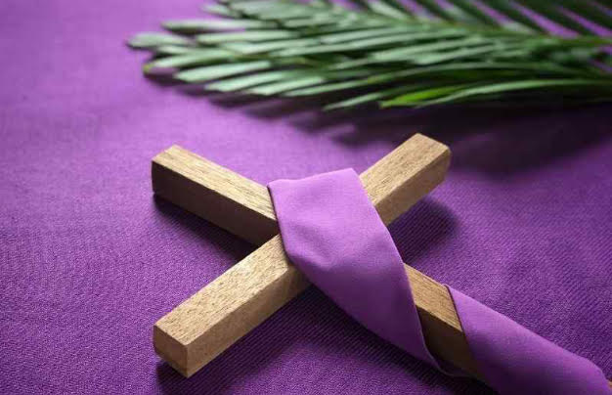
I can stand upon, and it never wavers.
Even in the midst of trials and tribulations,
I am secure in your love.
Fill me with hope, that I may face each day,
With confidence and trust in you.
In Jesus’ name, I pray, Amen.

The Building Hope Prayer- Dublin Diocese.
Pilgrim God, we give you thanks and praise.
You constantly journey with us even in
Our darkness and doubts.
We seek your way of loving kindness
To walk together as one family.
Open our eyes to recognise you in the
Faces of one another,
In the breaking of bread and in the
Splendour of creation.
May the risen Christ sow seeds of hope
And new life deep within us.
May our hearts and minds be filled with your word,
Bringing forth truth, justice and peace.
May the Holy Spirit working in and
Through us do much more
Then we can dare to imagine
As we live out our baptismal calling in
Humble and loving service.
We may this our prayer through Christ Our Lord. Amen.

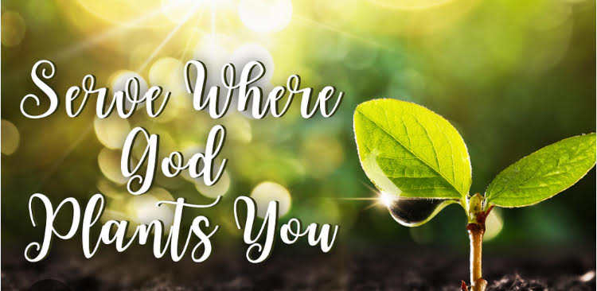

Praying for Racial Justice – 5th Week of Lent

Reading Isaiah 1:17.
Isaiah 1:17 (NIV): "Learn to do right; seek justice. Defend the oppressed.
Take up the cause of the fatherless; plead the case of the widow’’.
Brief pause

John 3: 18 – 21 (NLT) “There is no judgment against anyone who believes in him. But anyone who does not believe in him has already been judged for not believing in God's one and only Son. [19] And the judgment is based on this fact: God's light came into the world, but people loved the darkness more than the light, for their actions were evil. [20] All who do evil hate the light and refuse to go near it for fear their sins will be exposed. [21] But those who do what is right come to the light so others can see that they are doing what God wants."
Brief pause

REFLECTION:
Why did Isaiah focus so much on racial justice?
This verse encourages believers to actively seek justice and defend those who are oppressed, regardless of their background or social status.
The Hebrew word for justice refers not only to legal matters decided by courts but also to all matters of right behaviour and proper treatment of people. In Isaiah’s day, Judah tolerated various forms of discrimination – neglect of the needy, abuse of the poor, disregard for God’s covenant law, and sinful personal and social practices – much as our society does today. Through Isaiah, God told the Israelites that things were not as they should be – and warned them of judgement coming as a result. Because the people’s hearts were hard and set against obeying Him. Though the Israelites outwardly did what God had commanded, (Exodus 23:15) (Deuteronomy 16: 16) they resisted God inwardly. Their offerings had lost their true purpose and meaningless, so God went so far to ask the people of Judah to stop the nonsense altogether. (Isaiah1:13) God wanted their hearts and motives to be pure (Psalms 51:17) (Hosea 6:6) more than he wanted their sacrifices. Hypocritical adherence to ritual gives God no pleasure. So whatever we do as believers we should know that God sees it all, and He is displeased with racial justice, of any form. As believers, let us treat one another as brothers and sisters in Christ Jesus. Let’s put away racism and racial discrimination that has caused stress, and mental health issues to other people in our society, currently. (John 3: 18 – 21)

Song Give Us Your Peace (Michael Mahler)
Jesus, give us your peace, bring us together,
let all the fighting cease.
Shatter all our hearts of stone,
give us a heart for God alone.

PRAYER:
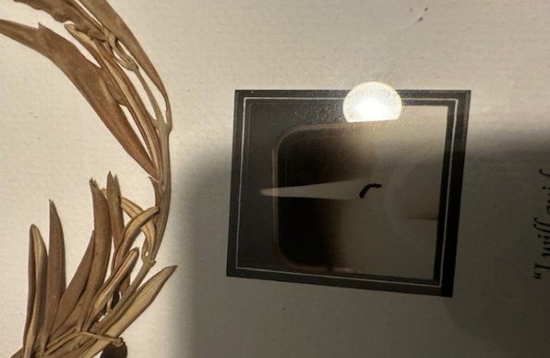
Let us pray,
Gracious and loving God,
We come before you today with hearts full of gratitude for the powerful message we have received on racial justice. Thank you for opening our eyes and stirring our hearts to the reality of racism and the call to stand against it.

All sing: O Lord, listen to my prayer, my prayer as I cry to you,
O Lord, listen to my prayer, my prayer as I cry to you.

Lord, we acknowledge that racism is a deep-rooted problem that continues to plague our society. We confess that at times we have been complicit in this sin, whether through our actions, our silence, or our ignorance. Forgive us, Lord, and help us to change our ways.
All sing: O Lord, listen to my prayer, my prayer as I cry to you,
O Lord, listen to my prayer, my prayer as I cry to you.

We pray for your guidance and strength as we seek to dismantle the systems of inequality and injustice that perpetuate racism. Fill us with your wisdom and compassion, that we may be agents of healing and reconciliation in our communities.
All sing: O Lord, listen to my prayer, my prayer as I cry to you,
O Lord, listen to my prayer, my prayer as I cry to you.

Grant us the courage to speak out against racism whenever we encounter it, even when it may be uncomfortable or unpopular. Help us to listen attentively to the experiences and stories of those who have been marginalised and oppressed because of their race. Give us empathy and understanding, that we may stand in solidarity with them.
All sing: O Lord, listen to my prayer, my prayer as I cry to you,
O Lord, listen to my prayer, my prayer as I cry to you.

Lord, we pray for unity among all races and ethnicities. Help us to recognise the inherent dignity and worth of every person, regardless of their skin colour or cultural background. May we celebrate the beautiful diversity you have created and work towards a world where everyone is treated with fairness, respect, and love.
All sing: O Lord, listen to my prayer, my prayer as I cry to you,
O Lord, listen to my prayer, my prayer as I cry to you

We lift up to you those who have been directly affected by racism, both past and present. Comfort those who have experienced discrimination, injustice, and violence. Heal the wounds that racism has caused and bring about restoration and reconciliation.
All sing: O Lord, listen to my prayer, my prayer as I cry to you,
O Lord, listen to my prayer, my prayer as I cry to you.

Lord, we commit ourselves to the ongoing work of racial justice. Give us the perseverance to continue fighting against racism, even when progress seems slow or discouraging. Help us to be instruments of change in our families, workplaces, schools, and communities. In Jesus name we pray.
All sing: O Lord, listen to my prayer, my prayer as I cry to you,
O Lord, listen to my prayer, my prayer as I cry to you.

Praying for Stillness - Palm Sunday

Reflection (Richard Hendricks OFM Cap)
Holy week begins with Palm Sunday, a time to reflect on the extremes within us. The same crowd who greet Jesus as King and Lord and sing Hosanna, will shout “crucify him!” barely a week later. It is a reminder to us all of the potential for both Good and Evil present within our hearts --just because we are crying out Hosanna in this moment, does not mean that we may not fall and find ourselves crucifying him in the next.
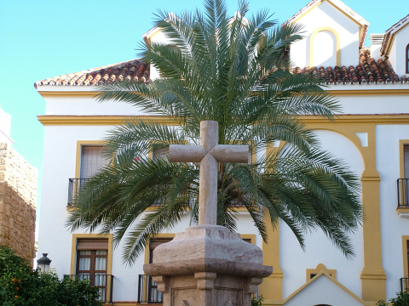
Palm Sunday, in its two Gospel passages, sobers us and gives us a vision of human reality; our reality. Beginning in joy and ending in sorrow, it reminds us what happens when we try and shrink God, when we try and manipulate him into what we want him to be, or even worse into what we want him to want us to be. The crowds shouting Hosanna do exactly this: they are good people, God fearing people even, and that may be their problem; they fear but they do not love. Love expands our understanding, fear shrinks it.

In their fear and anger their understanding is limited and so they want God to submit to them to follow their plan. They want Jesus to be their conquering messiah, a Warlord who raises an army and frees the Chosen people from their Roman overlords. They don't want what God wants to give -not a Warlord messiah but a suffering servant to free not just a city or a people from physical domination and slavery, but the whole cosmos from the slavery of Sin and Evil. They do not want it but they receive not a king upon a throne but a lamb upon a cross. And so Hosanna can turn to crucify so easily, so quickly, they can do that in my heart and in your heart too. Any time we try and shrink or constrain God to our plans, our way of thinking or our agendas, no matter how worthy or good they seem to be, this is what happens.
So, what is our way out of this mess? Jesus shows us. In all of the chaos of palms and processions; He is simply himself; silent, still, present to the will of the Father and empties Himself so that we may be filled. In the house of the high priest before Pilate and even on the cross he is simply following the will of the father and so He is serene, secure, still. He is the still point of pure love around which the world, even the cosmos turns and in his stillness he opens for us an ever expanding vision of God an ever expanding vision of love.
Meditation The Grail Prayer
Lord Jesus,
I give you my hands to do your work.
I give you my feet to go your way.
I give you my eyes to see as you do.
I give you my tongue to speak your words.
I give you my mind that you may think in me.
I give you my spirit that you may pray in me.
Above all,
| give you my heart that you may love in me
your Father and all mankind.
I give you my whole self that you may grow in me,
so that it is you, Lord Jesus,
who live and work and pray in me.

Song The Grail Prayer (Chris Walker)

Lenten Poem by Ann Weems
Lent is a time to take time to let the power
of our faith story take hold of us,
a time to let the events get up
and walk around in us,
a time to intensify our living unto Christ,
a time to hover over the thoughts of our hearts,
a time to place our feet in the streets of
Jerusalem or to walk along the sea and
listen to his Word,
a time to touch his robe
and feel the healing surge through us,
a time to ponder and a time to wonder….
Lent is a time to allow
a fresh new taste of God!
Perhaps we’re afraid to have time to think,
for thoughts come unbidden.
Perhaps we’re afraid to face our future
knowing our past.
Give us courage, O God,
to hear your Word
and to read our living into it.
Give us the trust to know we’re forgiven
and give us the faith
to take up our lives and walk.

Song You Are The Centre (Margaret Rizza)
All sing: You are the centre, you are my life,
You are the centre, O Lord, of my life.
Come, Lord, and heal me, Lord of my life,
Come, Lord, and teach me, Lord of my life.
You are the centre, Lord of my life.

