‘Menu’ for Family Activities
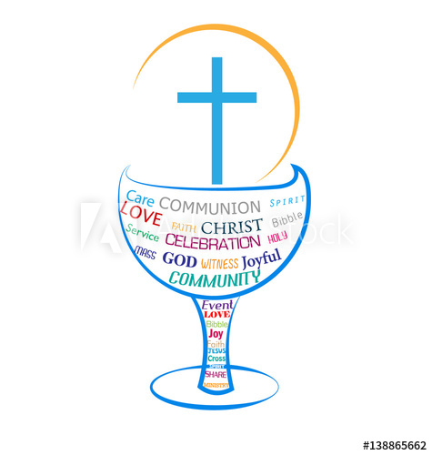
Each parish can choose from the menu the ideas it wants to offer to its families.
The idea is to make the waiting time a special time.
This in turn will make First Communion itself more special and meaningful.
Families could be encouraged to print out their own copy of the ideas.
ACTIVITY 1: A CHAT AND A WALK
Go for a family walk together.
Look out for 5 things to notice that you are thankful for.
Talk about them as you notice them.
Go back over them at home – with a ‘thank you’ prayer to God for all these things.
Prayer to say
‘Thank you, God, for this world we live in.
Thank you for all the beauty in nature.
Thank you for special things we notice when we pay attention.
Thank you for people around us.’

You can do this as often as you wish.
ACTIVITY 2: A PICTURE OF A SPECIAL MOMENT
Draw a picture of a special moment when you felt love at home.
Take your time over it and when you are ready, show it to your family.
Everyone sitting around – don’t say anything, let everyone look at it and think about it. Then all have a chat.
Prayer to say
‘Dear Lord, thank you for love.
Thank you for all the love between us.
We pray for people we love, including our grandparents and our relatives.
We pray for family members who are not well.
Thank you too for the ones who have died.
Help us to be more loving day by day.’

ACTIVITY 3: THINKING BACK ON THE DAY
A prayer together at bedtime. Think back on today.
Say ‘thank you God for…’
As many of you as want to, say a prayer.
Maybe also include other prayers e.g. for someone who is sick.
Finish with
God our Father, I come to say thank you for your love today.
Guard me in the dark of night and in the morning shed your light. Amen.
Glory be to the Father and to the Son and to the Holy Spirit,
as it was in the beginning, is now and ever shall be, world without end. Amen.

You can do this as often as you wish.
ACTIVITY 4: SAYING GRACE BEFORE MEALS
Decide together as a family that you will say the grace before meals.
‘Bless us, O God, as we sit together.
Bless the food we eat today.
Bless the hands that made the food.
Bless us, O God, Amen.’

Decide how often you will say it together.
ACTIVITY 5: SHARING MEMORIES OF SPECIAL FAMILY MEALS
Have a family chat to share memories of special family meals you have had.
What was your favourite one?
When will we have the next one?
Prayer to say
Dear God, thank you for our special times together.
When we share a meal together, we share our love for each other.
We look forward to First Communion,
the Mass where you share your love for us
as you give your son Jesus to us.

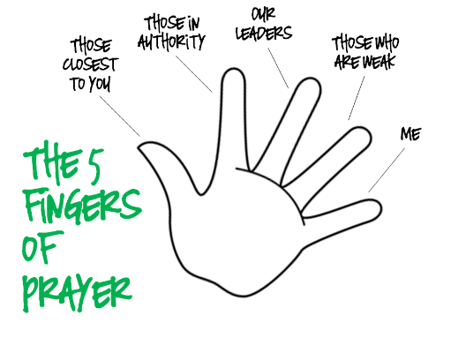
ACTIVITY 6: FIVE FINGER PRAYER
Say Pope Francis’ ‘5 Finger Prayer’ together
- Our thumb is closest to our heart
  - pray for the people close to your heart, your family and your friends, the special people in your life
- Our forefinger gives directions
  - pray for people who lead us and point us in the right direction, teachers in school, coaches in sport, doctors/nurses
- Our middle finger is the tallest
  - pray for our leaders who guide us, pray for God to guide them and make them wise and strong
- Our ring finger is the weakest
  - pray for the weakest people in our society, people who are ill or suffering, poor and struggling
- Our little finger comes last
  - when we have prayed for other people, we pray for ourselves as well
  - we pray for God’s care and protection and strength
ACTIVITY 7: A CHAT ABOUT FIRST COMMUNION MEMORIES
Arrange to have a chat with your grandparent(s) about First Communion – probably facetime or phone chat.
Say you want to ask them what First Communion means to them.
Ask them to tell you their favourite prayer.
You could do this with your parents/guardians too.
Share with each other your thoughts about what First Communion means to you, what it is all about.
Then say this prayer after communion together
Thank you, Lord Jesus,
O thank you for giving yourself to me.
Make me strong to show your love
wherever I may be.

ACTIVITY 8: WRITE A FIRST COMMUNION PRAYER

Write your own First Communion prayer.
Maybe build it up, bit by bit.
First, think of one thing you want to put in it, one line.
Then add to it every so often.

If you want, ask others in the family to write a line too, or to suggest an idea.
When it’s complete, have a special occasion when you say the prayer.
The parish might think about displaying the prayers at the First Communion itself.

ACTIVITY 9: VISIT THE CHURCH
Visit the church together. Find out when it is open during the day.
It is a lovely quiet place to sit. Make the sign of the cross.
Take time for that special prayer,
where you’re still and silent, and you know that God is there with you.
Light a candle and pray for special people and special intentions.
Say the ‘Glory be…’ prayer together.
Visit again, as often as you like – you are always welcome; this is always your place!


**The parish might think of setting up a family prayer space in a prominent position (e.g. where the Christmas crib is displayed). See the accompanying short video about how to go about this. Families could be encouraged to visit this space and share their own prayers.
ACTIVITY 10: FAMILY MASS LINK
If the parish is having a Family Mass ahead of First Communion,
it can insert its own activity idea here to encourage the family to take part
(whether in person or by webcam).

You could mention any ideas you have for the family to do something for the Mass, e.g. a prayer to include in the family prayer space.

