YEAR OF THE FAMILY – SEPTEMBER 2021
KITCHEN TABLE EXPERIENCES

Remember the recent TV advertisement about a boy who had issues around reading. His mother got him involved in cooking at home so that he would have to read the recipe over and over again. The penny dropped when he was older and he appreciated the subtle way his mother had encouraged and empowered him.

Have you any table stories like this one to tell?

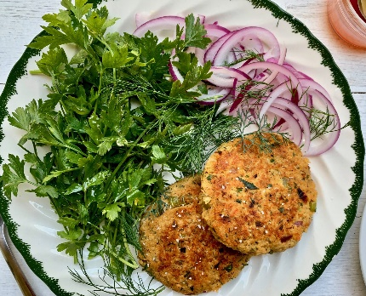
‘On my mother’s side of the family were slaves from the Maryland Eastern Shore. They developed their contemplative practices around meals. The informality of kitchen tables took the place of confessionals. Important life decisions were made as salmon cakes were shaped and collard greens were cut. Sunday meals were open to any who wanted to come. ‘
Barbara A. Holmes, Joy Unspeakable: Contemplative Practices of the Black Church, 2nd ed. (Fortress Press: 2017), xxxi, xxxii
Do you recognise this kind of table experience?

‘After countless meals together, often shared with family and friends, that table had become an icon of God’s grace and goodness. To take up a place at that table was to occupy sacred space. The people we loved most sat with us there. Meals were shared. Stories were told. Sins were confessed. We laughed together and cried together. Together we remembered where we’d been, and we dreamed of where we might one day go. We prayed at that table. And there we experienced God’s nearness, God’s kindness, and God’s love.’ The Dinner Table as a Place of Connection, Brokenness, and Blessing
Barry D. Jones Voice: Dallas Theological Seminary

Can you make the connection between kitchen table as a sacred space and the altar table?

Reading Matthew 9:10-17 (The Message)
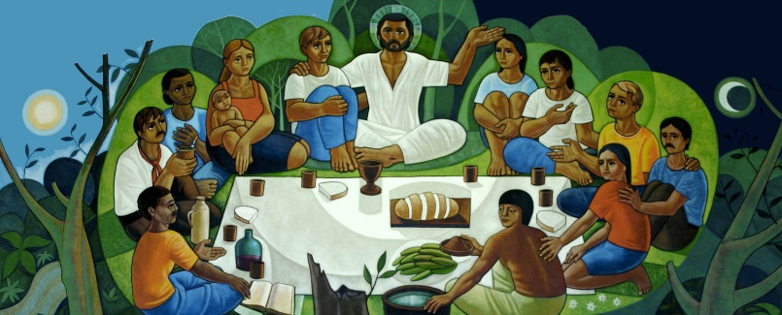
¹⁰⁻¹¹ Later when Jesus was eating supper at Matthew’s house with his close followers, a lot of disreputable characters came and joined them. When the Pharisees saw him keeping this kind of company, they had a fit, and lit into Jesus’ followers. “What kind of example is this from your Teacher, acting cosy with crooks and misfits?”
¹²⁻¹³ Jesus, overhearing, shot back, “Who needs a doctor: the healthy or the sick? Go figure out what this Scripture means: ‘I’m after mercy, not religion.’ I’m here to invite outsiders, not coddle insiders.”

The Dinner Table as a Place of Connection, Brokenness, and Blessing

A few months before we married, my wife and I purchased our first piece of furniture, a well-worn antique English pub table. We paid more for it than we could afford at the time, but it had just the right combination of refinement and scruff to suit our sense of style. And it fit nicely into our small apartment.
Perhaps before we invite people to Jesus or invite them to church, we should invite them to dinner
More than a decade later, when the time came to replace the pub table with something that better suited our growing family, we could not bring ourselves to get rid of it. After countless meals together, often shared with family and friends, that table had become an icon of God’s grace and goodness. To take up a place at that table was to occupy sacred space. The people we loved most sat with us there. Meals were shared. Stories were told. Sins were confessed. We laughed together and cried together. Together we remembered where we’d been, and we dreamed of where we might one day go. We prayed at that table. And there we experienced God’s nearness, God’s kindness, and God’s love.
Sharing tables is one of the most uniquely human things we do. No other creature consumes its food at a table. And sharing tables with other people reminds us that there’s more to food than fuel. We don’t eat only for sustenance.

The Table as a Place of Connection
Tables are one of the most important places of human connection. We’re often most fully alive to life when sharing a meal around a table. We shouldn’t be surprised, then, to find that throughout the Bible God has a way of showing up at tables. In fact, it’s worth noting that at the centre of the spiritual lives of God’s people in both the Old and New Testaments, we find a table: the table of Passover and the table of Communion. New Testament scholar N. T. Wright captured something of this sentiment when he wrote, “When Jesus himself wanted to explain to his disciples what his forthcoming death was all about, he didn’t give them a theory, he gave them a meal.”
One of the most important spiritual disciplines for us to recover in the kind of world in which we live is the discipline of table fellowship
I’m convinced that one of the most important spiritual disciplines for us to recover in the kind of world in which we live is the discipline of table fellowship. In the fast-paced, tech-saturated, attention-deficit-disordered culture in which we find ourselves, Christians need to recover the art of a slow meal around a table with people we care about. “Table fellowship” doesn’t often make the list of the classical spiritual disciplines. But in the midst of a world that increasingly seems to have lost its way with regard to matters of both food and the soul, Christian spirituality has something important to say about the way that sharing tables nourishes us both physically and spiritually. We need a recovery of the spiritual significance of what we eat, where we eat, and with whom we eat.
In Matthew’s account of the Last Supper, he writes, “While they were eating, Jesus took bread, and when he had given thanks, he broke it and gave it to his disciples, saying, ‘Take and eat; this is my body’” (Matt 26:26). The same pattern of language—blessing, breaking, and giving—also shows up in the accounts of Jesus’s miraculous feedings, as well as in the scene in which Jesus is recognized by the disciples with whom he had walked on the road to Emmaus. In his book Christ Plays in Ten Thousand Places, Eugene Peterson has observed that this pattern of being blessed, broken, and given is at the heart of the Christian story. There he rightly insists, “This is the shape of the Eucharist. This is the shape of the Gospel. This is the shape of the Christian life.”
The Table as a Place of Blessing
Food is my love language. The experts who write about such things suggest that each of us has one or two primary means by which we communicate (and receive) love. Those same experts don’t typically include food on their lists of love languages, but few things bring me more pleasure than working in the kitchen to prepare a meal for people I care about. Doing so is one of the primary ways I show people that I love them.
I’m becoming increasingly convinced that food is one of God’s love languages.
And I’m becoming increasingly convinced that food is one of God’s love languages. Think about it. The average human has about 10,000 taste buds. And the only explanation I can conceive for why that would be is that God loves us. Really loves us. After all, it didn’t have to be that way. God did not have to make us capable of experiencing such delight. He could have made us the sort of creatures for whom food is merely fuel. Our 10,000 taste buds are a display of grace, an expression of his love.
The table is a place to remember the blessing of God. One ancient prayer of the church (based on an even more ancient Hebrew prayer) says, “Blessed are you, O Lord God, King of the Universe, for you give us food to sustain our lives and make our hearts glad.” We need to recover the importance of gathering with people around our tables for the purpose of enjoying a meal as both a gift and means of grace. Such gatherings need not involve lavish spreads. They can, in fact, be quite simple. But they are those meals where we gather with guests and get a glimpse of the banquet of the kingdom to come, those meals where we get a little foretaste of the shalom of God. These meals are what the Celts called “thin places”—where the veil that separates heaven and earth seems exceedingly thin.

The Table as a Place of Brokenness
One of my favourite meal scenes in all of Scripture occurs on the banks of the Sea of Galilee after the resurrection of Jesus. It’s recorded in John 21. After a futile night of fishing, the disciples encounter Jesus, who calls out to them from the shore. Acting impulsively, as always, Peter dives into the water fully clothed in an effort to get to Jesus. As he emerges from the sea, dripping wet, he moves toward Jesus, who has made a fire on the beach. And at that moment he smells a hauntingly familiar smell. The word that John the storyteller uses to describe the fire that Jesus made is a word that occurs in only one other place in Scripture—earlier in his own story (John 18:18). There the word used is of the fire where Peter and the others warmed themselves on the night of Jesus’s arrest and trial. The charcoal fire of John 18:18 was the place of Peter’s denial. For Peter, shame had a smell—that of burning charcoal. But the charcoal fire of John 21 is the place of Peter’s restoration. The simple invitation of Jesus to his friend is, “Come and have breakfast” (21:12).
The table is the place where broken sinners find connection and belonging
The table is the place where broken sinners find connection and belonging. Despite our best intentions, we all, like Peter, stumble after Jesus. We desperately need people who will journey with us in our stumbling. We need to recover table fellowship as a spiritual discipline in order to strengthen the bonds of spiritual friendship among believers who are walking together on the road of discipleship.

The Table as a Place of Given-ness
As Christians, we are a people who are blessed, broken, and given. This latter aspect of our identity reminds us that as God’s people, we are given to the world—called to represent him. God’s mission is to rescue and renew his good but broken creation, and we are swept up into that mission and called to participate in it by announcing and embodying the love of God in Christ.
I’m convinced that our dinner tables have the potential to be the most “missional” places in all of our lives. Perhaps before we invite people to Jesus or invite them to church, we should invite them to dinner. If table fellowship is a spiritual discipline that is vital for shaping and sustaining our life with God for the world, we need to make a point to share our tables with people who are in our lives but far from God. This was one of the most distinctive aspects of Jesus’s ministry.
By his own admission, Jesus had a reputation among the religious establishment for being “a glutton and a drunkard” (Matt 11:18–19). One of the most distinctive things about him was that he ate and drank with “notorious sinners.” When the Pharisees called Jesus a glutton and a drunkard, they didn’t make up that depiction. They were referring to Deuteronomy 21:20 and implying that Jesus’s table fellowship with people who were far from God made him worthy of death. But for the Lord, that table fellowship was a demonstration of the in-breaking of the kingdom of God. As Gordon Smith suggests in his book A Holy Meal: The Lord’s Supper and the Life of the Church, “Eating was for Jesus a key means by which he proclaimed the coming of God’s reign and acted, or enacted, its arrival.” Recovering table fellowship as a spiritual discipline would mean reconnecting with this all-important aspect of Jesus’s life and ministry, and emulating him by opening our tables to people who are far from God.

The Coming Feast
In that day when all that is wrong is made right and all that is broken is made whole, there’s going to be one extravagant meal.
When the Old Testament prophets wanted to speak of the day when God’s reign would finally come in its fullness, they depicted a great feast. The great poet/prophet Isaiah spoke of a coming day when Yahweh will prepare “a feast of rich food for all peoples, a banquet of aged wine—the best of meats and the finest of wines” (Isa 25:6). In that day when all that is wrong is made right and all that is broken is made whole, there’s going to be one extravagant meal.
In her book Making Room: Recovering Hospitality as a Christian Tradition, theologian Christine Pohl has observed, “A shared meal is the activity most closely tied to the reality of God’s kingdom, just as it is the most basic expression of hospitality.” As we wait for the world to come and seek to navigate the complexity of the world that is, the church’s life will be nurtured and sustained as we recover the spiritual discipline of table fellowship.

