God’s Message to Joseph
The answers to the puzzle clues are found in Matthew 1:18–25 (but try to complete the
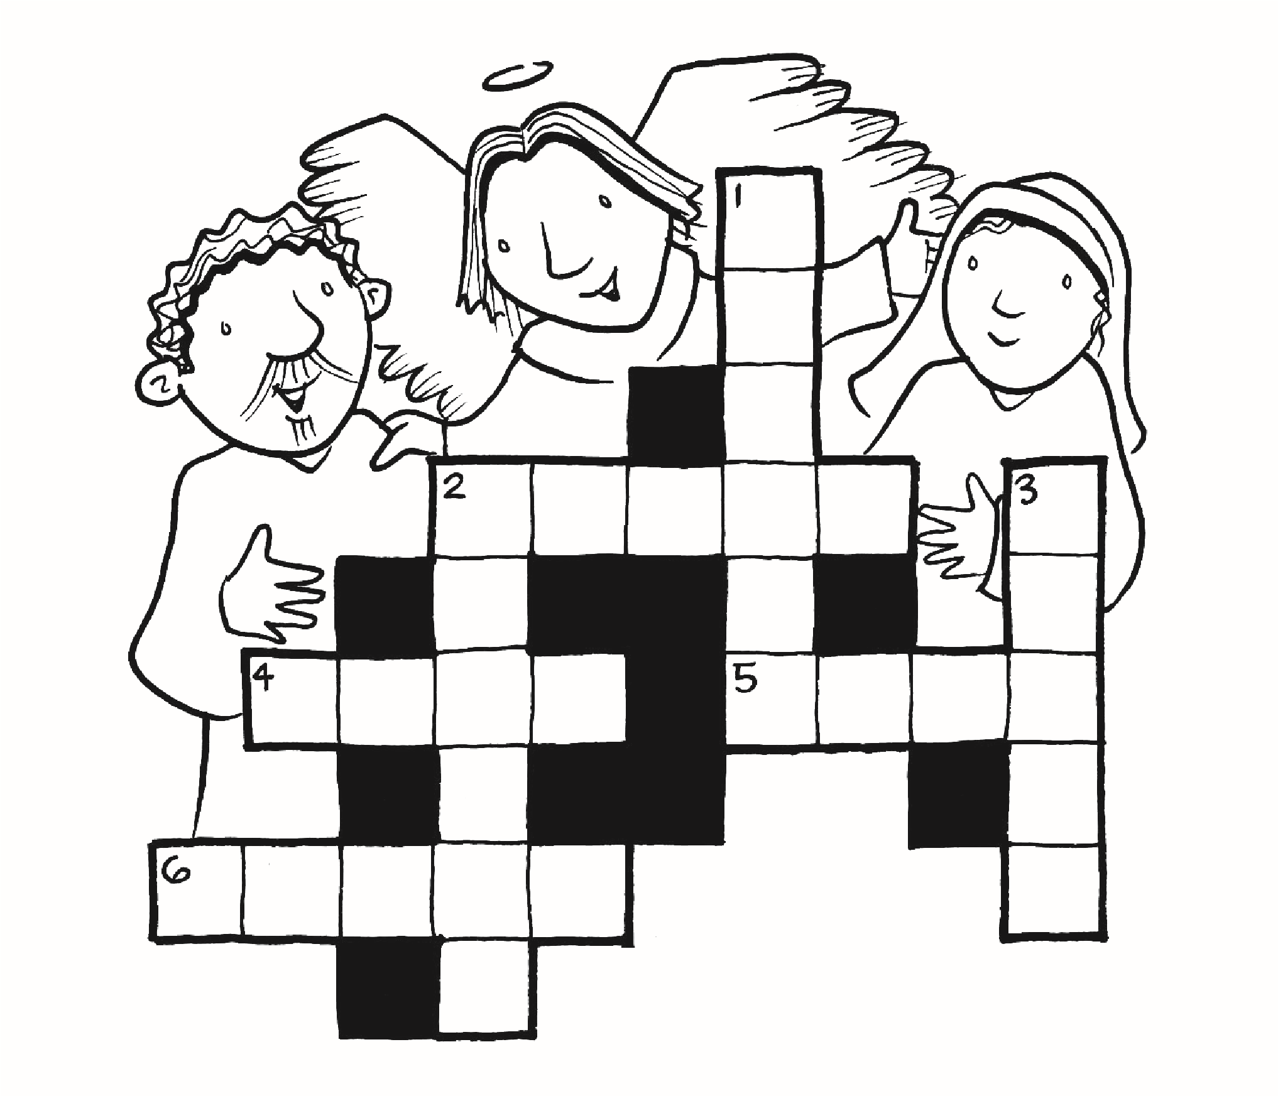
puzzle without looking!). Then read the Gospel passage to check your answers.
Across
2
. Who appeared to Joseph? ________________________
4
. Joseph’s wife-to-be was __________________________.
5
. Joseph decided to take Mary into his ________________.
6
. Joseph belonged to the family of ___________________.
Down
1
. Who had a dream? ______________________________
2
. The angel told Joseph not to be ____________________.
3
. The angel appeared in a __________________________.
Word Bank
David
angel
Joseph
afraid
home
dream
Mary

Joseph Was a Loving Father
What are the qualities of a good father? Write them around the picture of Saint Joseph
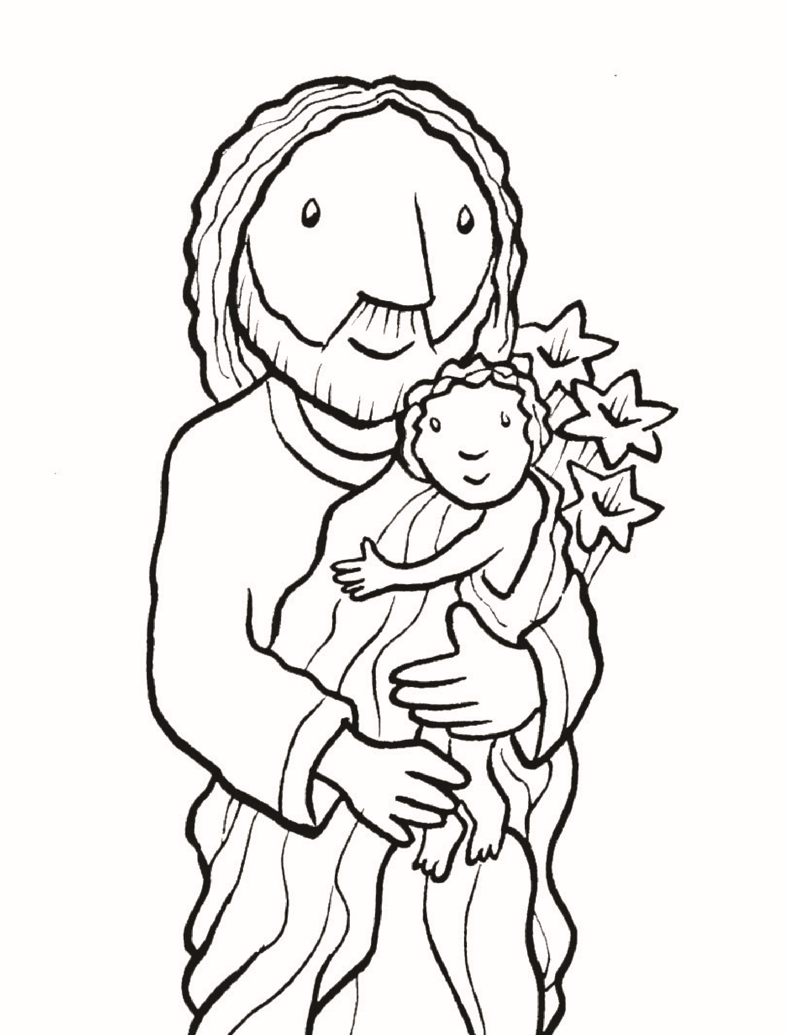
holding Baby Jesus. Then colour the picture.
© Pflaum Publishing Group, a division of Bayard, Inc. Art: © Bayard, Inc. – Illustration: Jim Burrows.
Permission is granted to reproduce this page for use by parishes, schools, and families using Pflaum Gospel Weeklies, Children Celebrate!, or the Children’s Liturgy of the Word videos by Miss Heidi (more info at https://linktr.ee/kidsliturgy). • 800-543-4383 • pflaum.com

Joseph Led His Family to Safety
After the Magi had visited them in Bethlehem, an angel came to Joseph in a dream. The angel told him to take Mary and Jesus to Egypt where Jesus would be safe from King Herod. Solve the maze to guide the Holy Family to safety in Egypt.
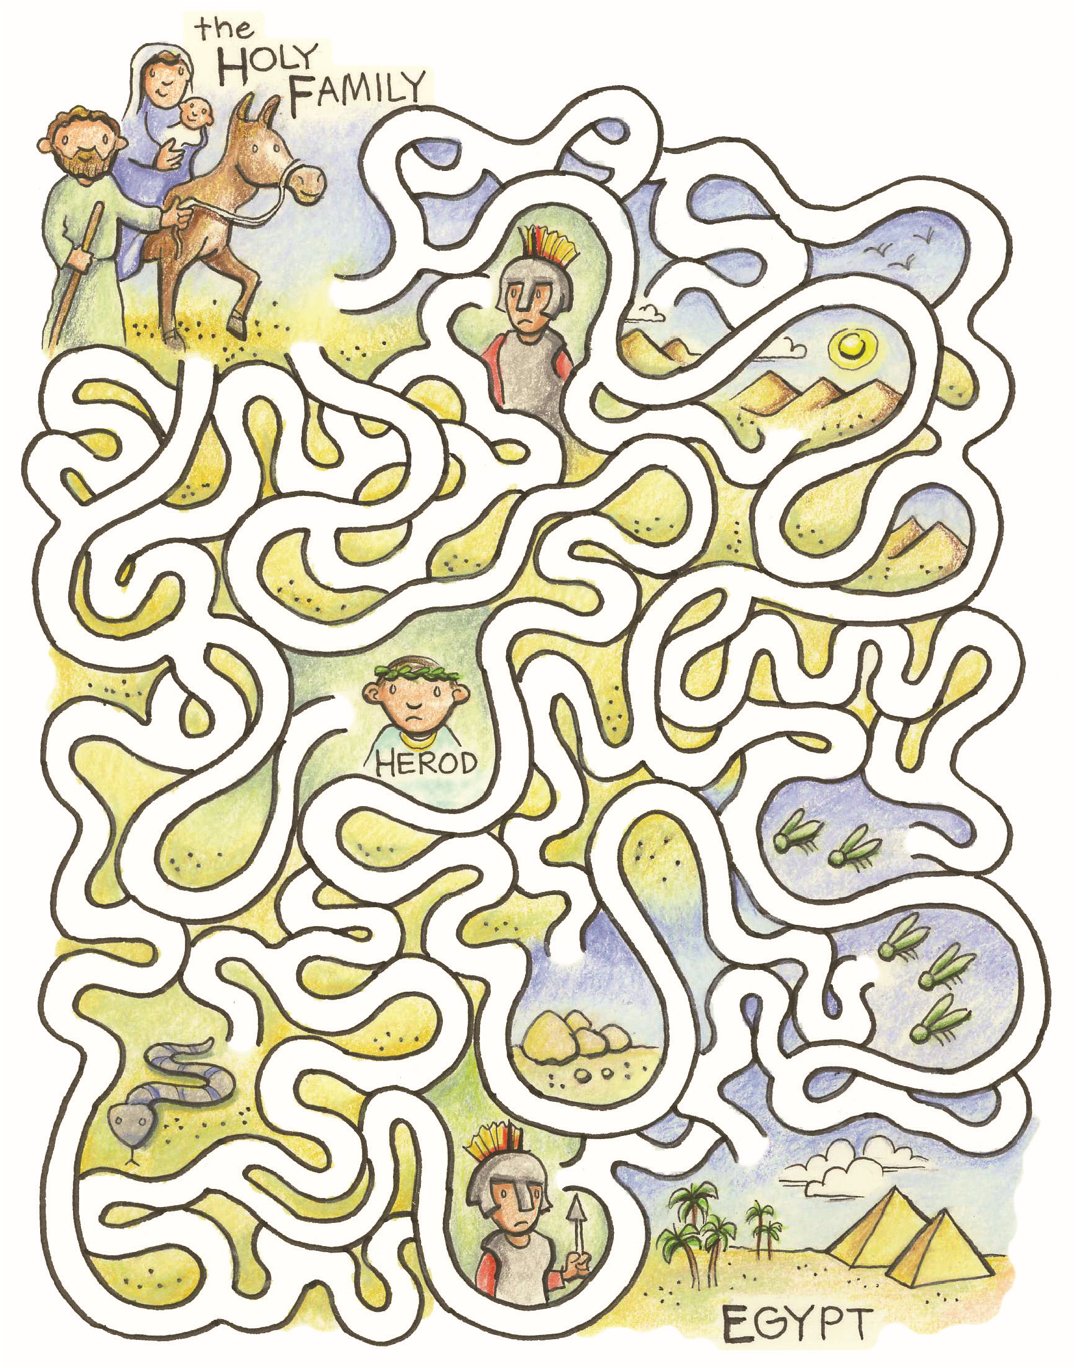

Learning About Saint Joseph
All that we know about Saint Joseph can be found in the first chapters of the Gospels of Matthew and Luke. Joseph was Mary’s husband and the foster father of Jesus. He was a good, hardworking man who protected his wife and child. Saint Joseph is honoured as the patron of many groups of people.
Find out which groups by putting an X through the squares on the grid that contain symbols or numbers.
% | & | A | £ | ¢ | L | L | O | $ | F | ! | T | ^ | H | E | # | S
~ | E | G | @ | ( | ( | R | ^ | O | 5 | U | 8 | 6 | P | # | S | 2
O | & | F | 5 | % | P | 8 | E | $ | O | P | + | ? | L | @ | E | !
Saint Joseph is the patron of .
T
H
P
H

Sharing Bread
Long ago in Italy, a drought caused the crops to fail. People prayed to Saint Joseph, asking for rain. Their prayers were answered, and they
celebrated with a great feast. It became the custom on Saint

Joseph’s Day (March 19) to prepare tables of food for the poor. Many Catholics still observe Saint Joseph’s Day by baking special breads and sharing them with hungry people. Before your meal today, pray this prayer:
Almighty God, the food on this table reminds us of your many good gifts. Bless this food and all of us. May the prayers of Saint Joseph, who provided bread for your Son, help us on our journey toward your heavenly kingdom. Amen.
© Pflaum Publishing Group, a division of Bayard, Inc. Permission is granted to reproduce this page for use by parishes, schools, and families using Pflaum Gospel Weeklies,
Children Celebrate!, or the Children’s Liturgy of the Word videos by Miss Heidi (more info at https://linktr.ee/kidsliturgy). • 800-543-4383 • pflaum.com
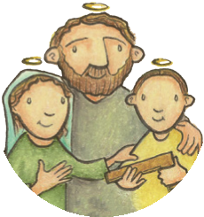
T
H
E

Y
E
A
R

O
F

S
A
I
N
T

J
O
S
E
P
H
T
H
E
Y
E
A
R

O
F

T
H
E

F
A
M
I
L
Y

Joseph Was a Loving Husband
Notice in this Gospel reading how Joseph protected Mary’s reputation.
“Now this is how the birth of Jesus Christ came about. When his mother Mary was betrothed to Joseph, but before they lived together, she was found with child through the holy Spirit. Joseph her husband, since he was a righteous man, yet unwilling to expose her to shame, decided to divorce her quietly.
Such was his intention when, behold, the angel of the Lord appeared to him in a dream and said, ‘Joseph, son of David, do not be afraid to take Mary your wife into your home. For it is through the holy Spirit that this child has been
conceived in her. She will bear a son and you are to name him Jesus, because he will save his people from their sins’ ” (Matthew 1:18–21).
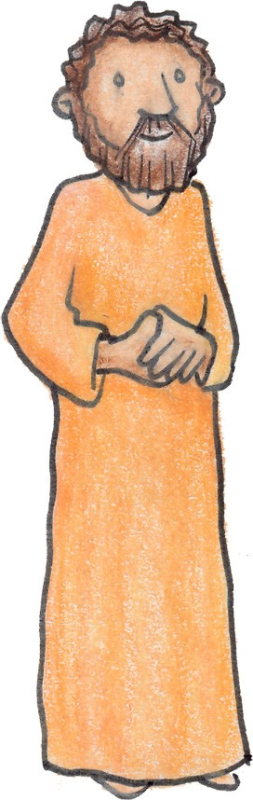
Joseph is described as a righteous, or just, man. Righteousness was one
of his good qualities. Describe your finest personal quality.
Liturgy of the Word with Children 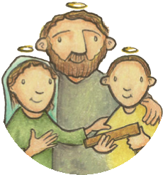
T
H
E

Y
E
A
R

O
F

S
A
I
N
T

J
O
S
E
P
H
T
H
E

Y
E
A
R

O
F

T
H
E

F
A
M
I
L
Y



Joseph Protected Mary and Jesus
Joseph loved Jesus’ mother, Mary. He also loved Jesus like his own son. Even though Mary had to give birth to Jesus in a stable, Joseph did his best to care for and protect Mary and Baby Jesus.
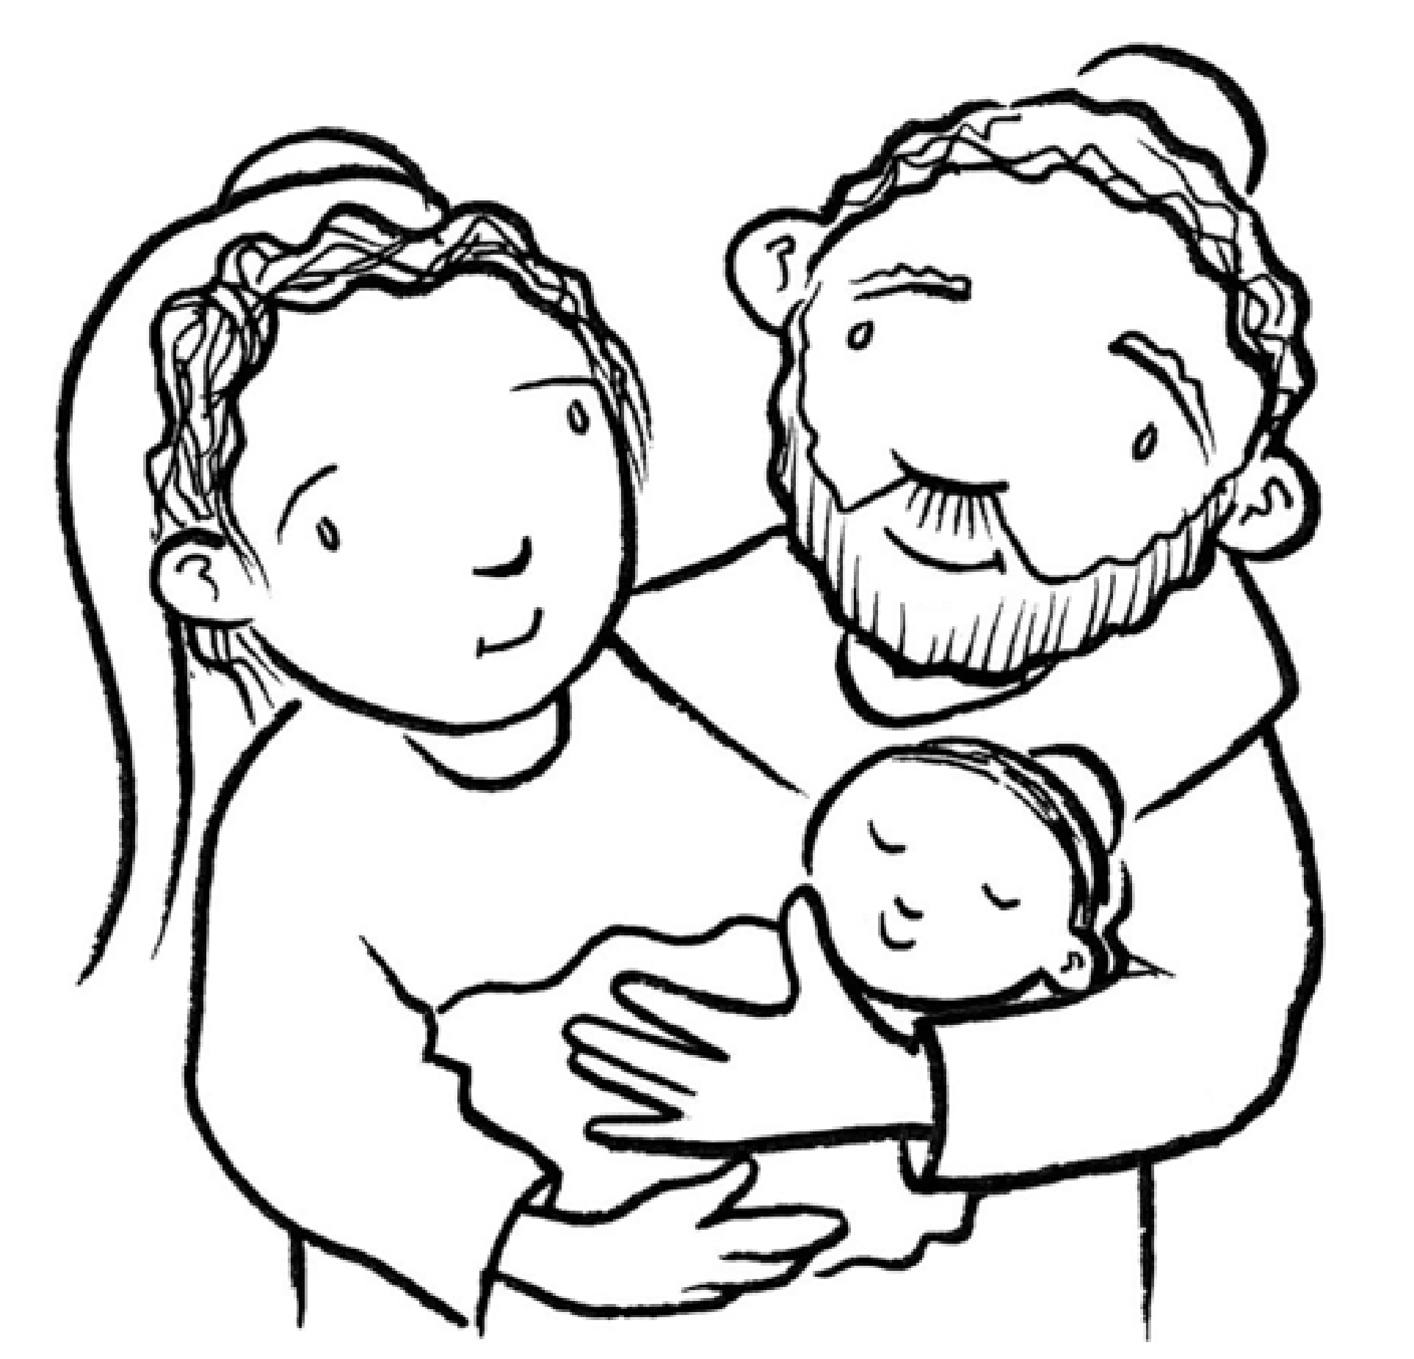
Liturgy of the Word with Children
T
H
E

Y
E
A
R

O
F

S
A
I
N
T

J
O
S
E
P
H
T
H
E
Y
E
A
R

O
F

T
H
E

F
A
M
I
L
Y

Joseph Was a Proud Father
Find Joseph in the two pictures. What feelings does his face show? How does he feel about Mary? How does he feel about his son, Jesus?
Find the six differences between the two pictures. Then enjoy coloring both pictures.
