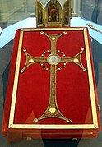
LitMus RESOURCE UPDATE

Sunday of the Word of God
24/25 January 2026 – 3rd Sunday of Ordinary Time

This Sunday of dedication began in 2022 under the late Pope Francis.
The Holy Father wanted “a Sunday given over entirely to the Word of God, so as to appreciate the inexhaustible riches contained in that constant dialogue between the Lord and his people” (Misericordia e misera, 7). It takes place during the Week of Prayer for Christian Unity, emphasising the important bond we have in Sacred Scripture with other Christian denominations and religious traditions.

For the launch in 2022 the Vatican suggested a focus on the Book of the Gospels.
“Listening to the Gospel, the high point of the Liturgy of the Word, is characterised by a special veneration, expressed not only by gestures and acclamations, but by the Book of the Gospels itself. One of the ritual possibilities suitable for this Sunday could be the entrance procession with the Book of the Gospels or simply placing the Book of the Gospels on the altar.”

Why not use the Book of the Gospels this Sunday and in fact on all Sundays and Solemnities?

Another Thought
Maybe you feel that the celebration of the Word of God in the Mass is a little rushed – too many words and not enough time to let it sink in. The late Pope Francis established a Sunday of the Word of God with the hope that this will help God’s people ‘to grow in religious and intimate familiarity with the sacred Scriptures.”
This might be an incentive for communities to offer a deeper experience of God’s Word in a more reflective atmosphere on a day when the Eucharist is not celebrated.
‘Stressing how essential it is for Catholics to familiarize themselves with Christ’s written word, Pope Francis stated that “a day devoted to the Bible should not be seen as a yearly event but rather a year-long event.”

Intercession
Let us pray for all who listen to the Word of God: that they will imbed what they have heard in their hearts and draw life from the scripture of the soul.

Saint Brigid’s Day 2026
Since the introduction of the Public Holiday in honour of Saint Brigid there is much more interest in the tradition surrounding her feast.
Padraigín Clancy, Parish Pastoral Worker in St. Columba’s, Iona Road is a folklorist and historian. These are some of her quotes on the subject:
“St. Brigid’s feast on 1st February, was originally a pre–Christian Celtic festival called Imbolg, which ushered in the soft balmy weather of Spring. At the centre of Celtic Spirituality, Brigid offers us an ancient awareness that connects with our feminine, intuitive and creative aspects and is vital for the world of our time “as we search for right relationship with the environment, with the self and with others.”
“There is no doubt that monasteries offered women an alternative to marriage. They also gave these early holy women a place to learn to read and to write. Monasteries were also great centres of craftwork, farming and places of refuge for the poor and the sick.”
“Traditionally, the rushes were plucked on Brigid’s Eve and laid on the doorsteps of houses. Then someone pretended they were Brigid and brought the rushes into homes – symbolically bringing new life into the homes,” explains Padraigin Clancy.

Saint Brigid’s Cross
Why not organise a gathering to prayerfully make St. Brigid’s Crosses and have them blessed at the Sunday liturgy? It would be a great project for the Confirmation Class to do together and then distribute them to those who are housebound in the community.

Intercession
Let us pray for women and men who have consecrated their lives to the service of God:
that, like Saint Brigid, they will continue to shine the light of Christ to all people by their generous living of gospel values.
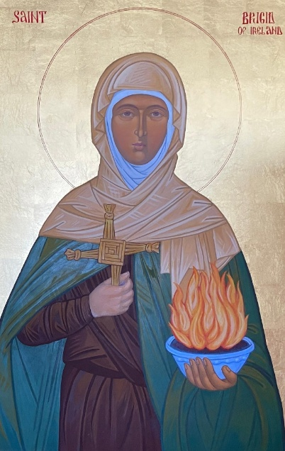

This Icon was commissioned by Saint Patrick’s College, Maynooth and written at the Redemptoristine Monastery of Saint Alphonsus, Drumcondra.

