

Pope Leo XIV has chosen the theme for the 34th World Day of the Sick,
which will be celebrated on February 11, 2026: “The compassion of the Samaritan: loving by bearing the pain of the other”.

The theme of the World Day of the Sick, focusing on the Gospel figure of the Samaritan who shows love by caring for the suffering man who fell into the hands of thieves, highlights this aspect of love of neighbour: love needs concrete gestures of closeness, through which we enter into the suffering of others, those who are ill, especially those who at the same time experience poverty, isolation, and loneliness .

The World Day of the Sick, established by St. John Paul II in 1992, is a privileged moment of prayer, spiritual closeness, and reflection for the entire Church and for civil society, who are all called to recognize the face of Christ in our sick and vulnerable brothers and sisters.

With the solemn celebration in Chiclayo, Peru, the Universal Church looks to Latin America and its rich tradition of solidarity. Like the Good Samaritan that bent down to help the injured man along the road, the Christian community is also called to stop and help those who suffer and be evangelical witnesses of closeness and service to the sick and most vulnerable.

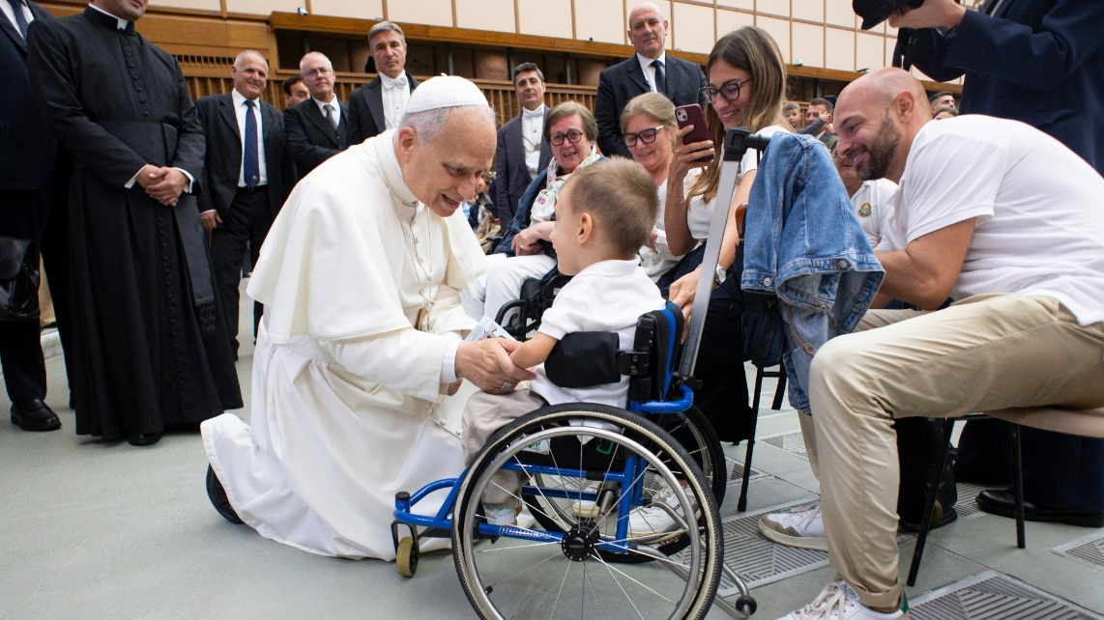

A Time of Prayer – World Day of the Sick 2026
(A liturgy from LitMus prepared in collaboration with the full-time
DCU Chaplaincy Students 2025/2026)

Setting the Scene
This prayer might be celebrated in the parish church, oratory, parish centre, nursing home, school or college. The layout will reflect the inclusion of people with disabilities or those who are sick who may need extra space and their carers. The Logo will be on the participation page or on a screen for all to see. Some see a parallel between the in and the tabernacle.
An image of Our Lady of Lourdes will also be displayed.
If possible, the setting could be circular to reflect community with a round table in the centre adorned with symbols and lights in the shape of a cross. The atmosphere will be welcoming, warm and safe. Available resources will determine these practical matters.

Gathering Song Holy Mary Full of Grace (Paul Décha)
All sing: When creation was begun,
God had chosen you to be
Mother of his blessed Son,
Holy Mary, full of grace.
Chorus: Ave, Ave, Ave Maria.
When creation was restored,
You were there beside the Lord
Whom you cherished and adored,
Holy Mary, full of grace.

Prayer Leader In the name of the Father and of the Son
and of the Holy Spirit.
All say: Amen.

Prayer Leader God welcomes us today as we take time and space to breathe, to pray and to worship together on this 34th World Day of the Sick – the Feast of Our Lady of Lourdes. The Gospel of the Samaritan who reached out in love to hold the pain of the victim of a robbery inspires our prayer – his heart literally went out to him.
This is the theme of our gathering:
“The compassion of the Samaritan: loving by bearing the pain of the other”.
Let us reflect for a moment on the Logo prepared for this celebration.
What do we see in it? …… How does it make us feel? ....
We might be drawn by the embrace of one for the other…the reaching out …. the flowing shape of the image….as we look again, we focus on the heart shape…. the cross of suffering or maybe a star of hope too.
What do the colours in the design say to us? How do we feel as we look at the Logo?
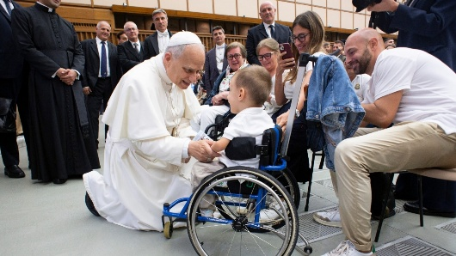
Pause

Instrumental Servant Song (Richard Gillard)
Reading Luke 10:25-37 (The Message)
From the Gospel of Luke
Just then a religion scholar stood up with a question to test Jesus.
“Teacher, what do I need to do to get eternal life?”
He answered, “What’s written in God’s Law? How do you interpret it?”
He said, “That you love the Lord your God with all your passion and prayer and muscle and intelligence—and that you love your neighbour as well as you do yourself.”
“Good answer!” said Jesus. “Do it and you’ll live.”
Looking for a loophole, he asked, “And just how would you define ‘neighbour’?”
Pause

Song Open My Eyes, Lord (Jesse Manibusan)
All sing: Open my eyes, Lord, help to see your face.
Open my eyes, Lord, help me to see.

Jesus answered by telling a story. “There was once a man traveling from Jerusalem to Jericho. On the way he was attacked by robbers. They took his clothes, beat him up, and went off leaving him half-dead. Luckily, a priest was on his way down the same road, but when he saw him, he angled across to the other side. Then a Levite religious man showed up; he also avoided the injured man.
Pause
All sing: Open my eyes, Lord, help to see your face.
Open my eyes, Lord, help me to see.

“A Samaritan traveling the road came on him. When he saw the man’s condition, his heart went out to him. He gave him first aid, disinfecting and bandaging his wounds. Then he lifted him onto his donkey, led him to an inn, and made him comfortable.
Pause
All sing: Open my heart, Lord, help me to love like you.
Open my heart, Lord, help me to love.

In the morning, he took out two silver coins and gave them to the innkeeper, saying,
‘Take good care of him. If it costs any more, put it on my bill—I’ll pay you on my way back.’
Pause
All sing: Open my heart, Lord, help me to love like you.
Open my heart, Lord, help me to love.
“What do you think? Which of the three became a neighbour to the man attacked by robbers?” “The one who treated him kindly,” the religion scholar responded.
Jesus said, “Go and do the same.”

All sing: Open my ears, Lord, help me to hear your voice.
Open my ears, Lord, help me to hear.
Pause


Reflections
Where do we see ourselves in the story? Would we be afraid that it was a trap? Would it expose our own vulnerabilities? Do we see limitations but don’t let it stop us?
Did our hearts go out to the battered one?
The innkeeper might represent the wider community that we can draw on when we find someone in need of care.
What did the others not see as they passed by – thinking of how they might be seen?
How comfortable would we be with bandaging and disinfectant even if we were qualified to do it? Do we like to keep our distance?
Have you been the person passed by in moments of pain by family, carers or medical professionals? What did that feel like? Did someone notice your condition, answer your call or at least listen to you? Do you find the support of your faith at these times?

Have you been a family member in an ICU unit keeping vigil and the caring staff brought you tea, coffee, water, biscuits or even blankets if you had to stay the night? Let us give thanks for those who go the extra mile when they see the need of others.
Maybe you have gone through recovery programmes of rehabilitation or physiotherapy, and you know that the medical professionals have shown you amazing encouragement?
Perhaps, you are blessed with your carers both family and professional who carry you?
Being a carer can be a pain in the neck at times. They mirror the Samaritan in ‘loving by bearing the pain of the other’.

Song Stand Beside Me (Columba McCann OSB)
(Stand beside me, walk before me, hold and shelter me touch and heal me)

Turn to the person beside you – exchange names or make some gesture. Don’t be afraid of connectedness. They are the ties that hold us together.
Embrace yourself with a generous hug of love and self-worth or place your hand on your own heart.

Prayer
All say: Loving God,
Bless the lonely and those in need of neighbours.
Inspire us to imitate the Samaritan:
By noticing those around us who require help
By acting without discrimination to reach out
By going the ‘extra mile’ of care and anointing
We ask this, in the Spirit, through Christ, Our Lord.
Amen.

Song The Servant Song (Richard Gillard)
Will you let me be your servant,
Let me be as Christ to you;
Pray that I may have the grace to
Let you be my servant, too.
We are pilgrims on a journey,
We are trav'lers on the road;
We are here to help each other
Walk the mile and bear the load.
I will hold the Christ-light for you
In the night-time of your fear;
I will hold my hand out to you,
Speak the peace you long to hear.
I will weep when you are weeping;
When you laugh I'll laugh with you.
I will share your joy and sorrow
'Til we've seen this journey through.
When we sing to God in heaven
We shall find such harmony,
Born of all we've known together
Of Christ's love and agony.

Prayer Let us pray,
All say: God of providence and care,
Give me the courage to go out of my comfort zone
Help me to reach out to the stranger in need
Lead me towards those who I often ignore
We ask this through Christ, our Lord. Amen.

Song Alabaré (I Will Praise) or The Samaritan (Marigold Loves Jesus on You Tube)

All sing: Alabaré! Alabaré! Alabaré a mi Senor.
Alabaré! Alabaré! Alabaré a mi Senor.

Hospitality
Hospitality is at the heart of this Gospel story with a strong intercultural element too. A warm, genuine welcome is important and plenty of help from the community. If possible, the hospitality would take place in the same space as the prayer. Food served might capture a flavour of the Middle East with dates and pastries as easy examples.
Everyone can be given a cup cake or scone to take away to share with others. Hot Cross Buns could be laid out in the sacred space in the form of a cross with lights around them to reflect the cross of hope on the logo. Friendship bracelets might also be a parting gift to celebrate connectedness.

